

Papyrus Guidelines



Version 1.1.00

January 31, 2016

ONF TR-515

Work in progress!

­ONF Document Type: Technical Recommendation

ONF Document Name: Papyrus Guidelines V1.1.00

**Disclaimer**

THIS SPECIFICATION IS PROVIDED “AS IS” WITH NO WARRANTIES WHATSOEVER, INCLUDING ANY WARRANTY OF MERCHANTABILITY, NONINFRINGEMENT, FITNESS FOR ANY PARTICULAR PURPOSE, OR ANY WARRANTY OTHERWISE ARISING OUT OF ANY PROPOSAL, SPECIFICATION OR SAMPLE.

Any marks and brands contained herein are the property of their respective owners.

Open Networking Foundation

2275 E. Bayshore Road, Suite 103, Palo Alto, CA 94303

[www.opennetworking.org](http://www.opennetworking.org)

©2015 Open Networking Foundation. All rights reserved.

Open Networking Foundation, the ONF symbol, and OpenFlow are registered trademarks of the Open Networking Foundation, in the United States and/or in other countries. All other brands, products, or service names are or may be trademarks or service marks of, and are used to identify, products or services of their respective owners.

Content

1 Introduction 6

2 References 6

3 Abbreviations 6

4 Documentation Overview 7

5 Getting Papyrus Running 8

5.1 Downloading Eclipse 9

5.2 Installing Papyrus 10

5.3 Importing a Model 15

5.4 Deleting a Project 19

6 Information Model on GitHub 20

6.1 ONFInfoModel Structure on GitHub 20

6.2 GitHub Work Flow 21

6.3 Downloading a Model from github for “Read Only Use” 37

7 Using Papyrus 39

7.1 Illustrative Profile and Model 39

7.2 Papyrus File Structure 40

7.3 Model Splitting 41

7.4 Team UML Model Development 42

7.5 Developing a Sub-Model 45

8 Extracting Data from a Papyrus model 47

8.1 Gendoc Plugin 48

8.2 Installing Gendoc 48

8.3 Using Gendoc 50

8.4 Papyrus Table 50

9 Importing RSA Models into Papyrus 54

9.1 Import RSA Model into Papyrus 54

9.2 Replace RSA Profile by Papyrus Profile 56

9.3 Remove the “old” RSA files 57

Annex A Using Gendoc 58

A.1 Template usage 58

A.2 Basic template 59

A.3 Cover, contents, closing text etc 60

A.4 Figures from the model with interleaved text 60

A.5 Figure in alphabetical order with no interleaved specific text 62

A.6 Further explanation of the script 62

A.7 Test template for printing diagrams and associated text 62

A.8 Data Dictionary template overview 63

A.9 Adding the class and its stereotypes 63

A.10 Adding properties and stereotypes in tabular form 65

A.11 Adding complex data types 67

A.12 Adding other data types 67

A.12.1 Enumeration Types 67

A.12.2 Primitive Types 68

A.13 Example complete template 69

A.14 Extending the template 69

A.15 Known issues 69

List of Figures

Figure 4.1: Specification Architecture 8

Figure 5.1: Eclipse Download Page 9

Figure 5.2: Content of the Eclipse Folder after Extracting the Zip-file 9

Figure 5.3: Initial Welcome Page of Eclipse 10

Figure 5.4: Installing Papyrus (1) 11

Figure 5.5: Installing Papyrus (2) 11

Figure 5.6: Installing Papyrus (3) 12

Figure 5.7: Proxy Configuration 13

Figure 5.8: Open Papyrus Perspective 14

Figure 5.9: Required Display Setting 15

Figure 5.10: Papyrus Project Explorer / Model Explorer 15

Figure 5.11: Papyrus Model Structure 16

Figure 5.12: Importing a Model (1) 17

Figure 5.13: Importing a Model (2) 18

Figure 5.14: Open a Model 19

Figure 5.15: Delete a Project 20

Figure 6.1: Initial ONFInfoModel Structure on GitHub 21

Figure 6.2: GitHub Work Flow 22

Figure 6.3: Open Git Perspective 23

Figure 6.4: Add Repository Choices 23

Figure 6.5: Location of the Repository Address 24

Figure 6.6: Source Git Repository Window 25

Figure 6.7: Branch Selection Window 25

Figure 6.8: Local Destination Window 26

Figure 6.9: develop Branch Cloned to Local PC 27

Figure 6.14: develop branch shown in Papyrus Project Explorer (snapshot) 27

Figure 6.15: NbiTopologyModule Shown in Papyrus Model Explorer 28

Figure 6.16: Importing UML Primitive Types 28

Figure 6.17: Importing Core Model Artifacts 29

Figure 6.18: Selecting Core Model Artifacts 30

Figure 6.19: Imported Core Model Artifacts 31

Figure 6.20: Unstaged Changes in Git Staging 32

Figure 6.21: Add Files to Git Stage 32

Figure 6.22: Staged Changes in Git Staging 32

Figure 6.23: Push Updated Branch to Remote Repository 33

Figure 6.24: Push Confirmation Window 34

Figure 6.25: Compare in Modeler’s Remote Repository 35

Figure 6.26: Detailed Comparison in Modeler’s Remote Repository 35

Figure 6.27: Pull Request in Modeler’s Remote Repository 36

Figure 6.28: Pull Request in Administrator’s Remote Repository 36

Figure 6.25: Download ONFInfoModel Repository 37

Figure 6.26: Extract ONFInfoModel Repository to Worksoace 37

Figure 6.27: Making the ONFInfoModel visible in Papyrus (1) 38

Figure 6.28: Making the ONFInfoModel visible in Papyrus (2) 38

Figure 7.1: Illustrative UML Profile 39

Figure 7.2: Illustrative Core Model 40

Figure 7.3: Profile Associated to the Model 40

Figure 7.4: Papyrus File Structure 40

Figure 7.5: Papyrus File Structure after Splitting 41

Figure 7.6: Imported UML Artifacts 42

Figure 7.7: Information Model File Structure 43

Figure 7.8: Importing an Existing Project into Papyrus 43

Figure 7.9: Project and Model Explorer View after Import into Papyrus 44

Figure 7.10: Modeling Process over Time 45

Figure 7.11: Example Sub-Model A (highlighted in red) 46

Figure 7.12: Updated Sub-Model A Files (highlighted in blue) 47

Figure 8.7: Installing Gendoc (1) 48

Figure 8.8: Installing Gendoc (2) 49

Figure 8.9: Installing Gendoc (3) 50

Figure 8.1: Model Selection 50

Figure 8.2: Class Expansion 51

Figure 8.3: Create new empty Table 52

Figure 8.4: Artifact Selection 52

Figure 8.5: Creation of Excel Sheet (1) 53

Figure 8.6: Creation of Excel Sheet (2) 53

Figure 9.1: Installing Papyrus Component “RSA Model Importer” 54

Figure 9.2: : Importing .emx Model 55

Figure 9.3: Associated Papyrus Profile 56

Figure A-1: Initiating Gendoc for a particular template 58

List of Tables

None.

Document History

|  |  |  |
| --- | --- | --- |
| **Version** | **Date** | **Description of Change** |
| 1.0 | March 13, 2015 | Initial version |
| 1.1 | Nov. 30, 2015 | Version 1.1 |
| 1.1.00 | Jan. 31, 2016 | References section upated. ONF specific text neutralised. OpenModelProfile now in EAGLE; related text updated. Work flow for OpenModelProfile added in section 6.1. Papyrus installation procedure updated (no separate Eclipse installation). |

# Introduction

This Technical Recommendation defines the guidelines that have to be taken into account during the creation of a protocol-neutral UML (Unified Modeling Language) information model using the Open Source tool Papyrus. The Guidelines are not specific to any SDO, technology or management protocol. References are written in an SDO-neutral form, enclosed by “{ }”; each SDO will have an SDO-specific “mapping table” for these placeholders:

* XxxModel  
  Any Papyrus UML model.
* {XxxModel}  
  Identifies the URI of the GitHub repository containing the XxxModel.

**Summary of main changes between version 1.0 and 1.1**

The following guidelines have been changed/added:

* Eclipse: Migration from Kepler to Mars
* Github: Only one develop branch
* Github: Method for retrieving repositories using the "Download ZIP" button added; this method is just for read only users
* Documentation: New section on Gendoc added.

# References

1. Papyrus Eclipse UML Modeling Tool (<https://www.eclipse.org/papyrus/>)
2. Eclipse (<https://eclipse.org/>)
3. Unified Modeling Language™ (UML®) (<http://www.uml.org/>)
4. ONF TR-514 “UML Modeling Guidelines 1.1” (https://www.opennetworking.org/images/stories/downloads/sdn-resources/technical-reports/UML_Modeling_Guidelines_Version_1-1.pdf)
5. Open Source SDN Community  
   (<http://opensourcesdn.org/>)
6. Open Source SDN Project EAGLE  
   (<https://github.com/OpenNetworkingFoundation/EAGLE-Open-Model-Profile-and-Tools>)
7. OpenModelProfile  
   (https://github.com/OpenNetworkingFoundation/EAGLE-Open-Model-Profile-and-Tools/tree/OpenModelProfile)

# Abbreviations

API Application-Programming-Interface

ARO Association Resources Online™

ASCII American Standard Code for Information Interchange

DS Data Schema

IDE Integrated Development Environment

IM Information Model

IMP Information Modeling Project (ONF Services Area)

ITU-T International Telecommunication Union – Telecommunication Standardization Sector

JSON JavaScript Object Notation

NBI NorthBound Interface

OF Open Flow

OT Optical Transport

RSA Rational Software Architect (UML tool from IBM)

SDO Standards Developing Organization

UML Unified Modeling Language

URI Uniform Resource Identifier

URL Uniform Resource Locator

XML Extensible Markup Language

WG Working Group

# Documentation Overview

This document is part of a series of Technical Recommendations. The location of this document within the documentation architecture is shown in Figure 4.1 below:



Figure 4‑1: Specification Architecture

# Getting Papyrus Running

The Open Source UML tool Papyrus is a plug-in for the Open Source integrated development environment (IDE) Eclipse.

Current tool versions:

* Eclipse version 4.5.x “Mars” (4.5.1)
* Papyrus version 1.1.x (1.1.3)
* Gendoc version 0.5.x (0.5.1)

This section explains how to get Papyrus running on your PC and how to import a model. Working with sub-models is described in section .

## Downloading Papyrus

Papyrus can be downloaded from here: <https://eclipse.org/papyrus/download.html>. The software package contains already the corresponding Eclipse software; i.e., Eclipse need not be available on your PC. Papyrus is available for various platforms:

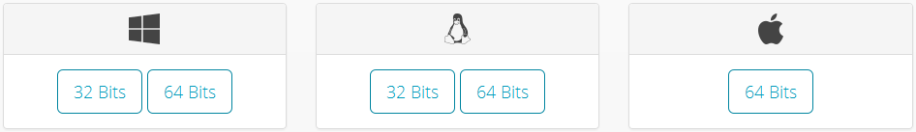

Figure 5‑1: Papyrus Download Page

 Papyrus Mars release (1.1.3) requires a 1.7 compatible JVM. 

You cannot “install” Papyrus on the PC; just extract the downloaded zip-file:

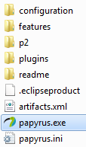

Figure 5‑2: Content of the Papyrus Folder after Extracting the Zip-file

To launch Papyrus, double-click on the  file.



Figure 5‑3: Initial Papyrus Welcome Icon

After launching Papyrus, a default  folder is created in the home directory (…/users/<users name>/). The workspace configuration information is contained in the folder:  
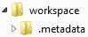.

Any empty (need not be empty but is recommended) folder - anywhere - can be used as a workspace-folder. The workspace can be selected during the launch of Papyrus.

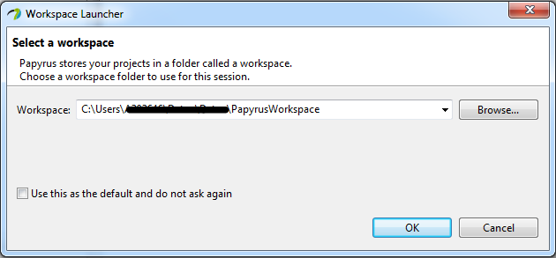

Figure 5‑3: Selecting a Workspace

## Importing a Model

The Papyrus Perspective shows a Project Explorer and a Model Explorer:

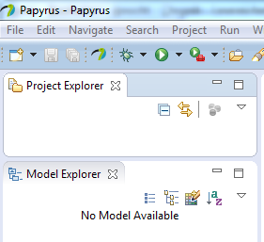

Figure 5‑5: Papyrus Project Explorer / Model Explorer

Notes:  
Models cannot exist on their own. Every model needs to be contained in a project. A project can contain zero or more models.  
The  window provides a view on the model files in the workspace-folder. The  window provides the internal view of the model selected in the . The  can only show (edit) one model at a time.

The actual interface specification is contained in the Information Model and the additional properties of the UML artifacts are defined in a Profile Model. It is possible to organize the two models in a single project (*Alternative 1* in the figure below) or in two separate projects (*Alternative 2* in the figure below).

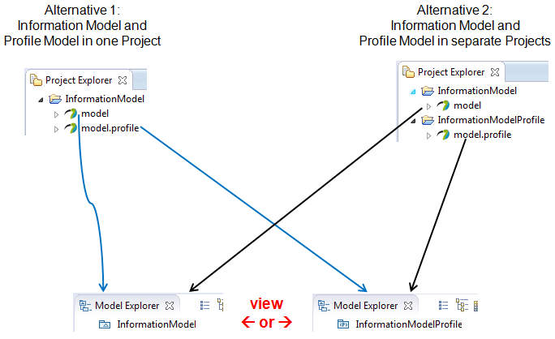

Figure 5‑6: Papyrus Model Structure

Note:  
The following model import description is based on Alternative 2; i.e., Model and Profile (OpenModelProfile) are in separate projects.

There is a single OpenModelProfile which should be used by all participating SDOs. The latest version is available from the [EAGLE Open Source SDN project](https://github.com/OpenNetworkingFoundation/EAGLE-Open-Model-Profile-and-Tools/tree/OpenModelProfile) [6]:  
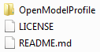

Section 6.1 explains how to access the OpenModelProfile from GitHub.

The Model can be downloaded from {XxxModel}:  
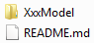

Each folder contains a .project, .di, .notation and .uml files.

The next step is to import the OpenModelProfile files and XxxModel files into Papyrus.

 The Profile should be imported first.   
 It is also possible to import the Model first,  
 but the Profile must be available before you open the model the first time.

Right click in the  area opens the menu containing the -button:

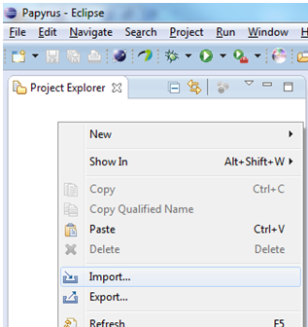 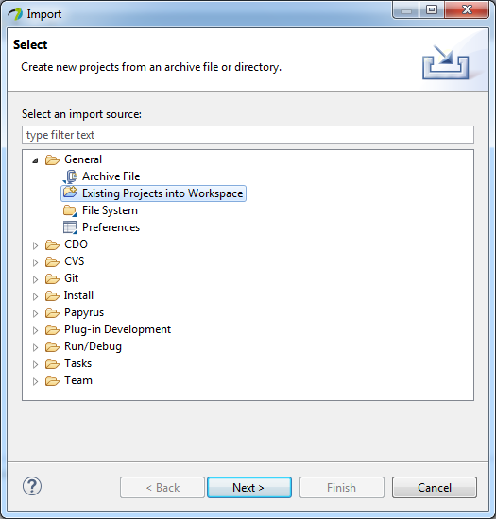

Figure 5‑7: Importing a Model (1)

You need to select the  option when the profile - that you want to import - contains a  file. Otherwise you need to create a new project and then import the profile using the  option.

Click  and then point via 

* to the folder containing the extracted files: 
* to the zip-file containing the files: .

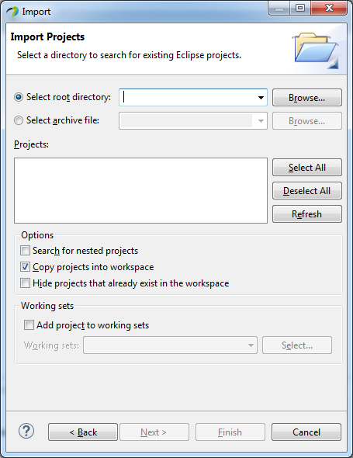

Figure 5‑8: Importing a Model (2)

THEN select the option  if you want the Profile files copied into your workspace, otherwise Papyrus only creates a pointer and works with the files contained in the extracted folder:  
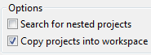

Click .

Note:  
The profile/model files can be located anywhere on the PC. It is not necessary to copy the files into the workspace-folder.

The Model is imported in the same way as the Profile.

A double click e.g., on  in the  opens the XxxModel in the :

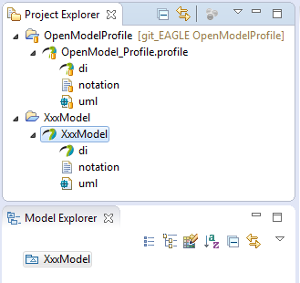

Figure 5‑9: Open a Model

Now you can start working with the model.

## Deleting a Project

Projects can be deleted from the  by a right click on the project (e.g., ) and selecting .

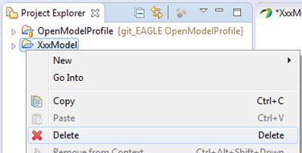

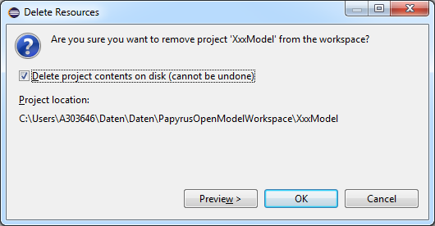

Figure 5‑10: Delete a Project

# GitHub Usage



Wikipedia: “*Git is a widely-used source code management system for software development. It is a distributed revision control system with an emphasis on speed, data integrity, and support for distributed, non-linear workflows.*”

Git is a protocol which allows managing data in repositories on hosts. Such hosts are provided by many companies and organisations.



GitHub is a web-based git repository hosting service.

Note:  
These Guidelines describe the usage of repositories stored in GitHub. The usage of other hosting services is similar.

The work flow recommended in these Guidelines is based on the usage of four repositories:

* a repository on GitHub containing the published files
* a copy of the published repository located in my (user/modeler) remote repository on GitHub
* a copy of my remote repository located on my local PC
* a copy of my local repository in my local working directory  
  (all changes done by me will initially be stored in this working directory)



Figure 6‑1: Recommended Repositories

## OpenModelProfile on GitHub

The OpenModelProfile contains an SDO-neutral definition of additional properties for UML artifacts. The additional properties are described in the UML Modeling Guidelines [4]. The OpenModelProfile is published in a repository of the ONF Open Source project EAGLE [6]; which is part of Open Source SDN [5].

The following steps describe the recommended work flow for downloading the OpenModelProfile to the local PC for usage in Papyrus.

The steps correspond with the numbers  in Figure 6‑2.



Figure 6‑2: Recommended Work Flow for OpenModelProfile Download

1. The OpenModelProfile is published in a repository of the ONF Open Source project EAGLE (<https://github.com/OpenNetworkingFoundation/EAGLE-Open-Model-Profile-and-Tools>).
2. The modeler needs to copy the repository into its own GitHub space; by clicking :  
     
     
     
   A copy of the complete repository is now contained in the modeler’s GitHub space:  
     
     
     
   The URI pointing to this repository is provided here:  
     
   
3. The EAGLE repository contains the OpenModelProfile branch (besides other branches). In step 2 we clone just the OpenModelProfile branch to the local repository. This is done using the git client that is contained in the Eclipse tool on the local PC.

 Make sure that the Eclipse workspace that is selected during launch of   
Eclipse does not contain already the OpenModelProfile project.

Note:  
More than one version of the model can only be maintained on the local PC if they are in different Eclipse Workspaces.

After the Eclipse has been launched in the local PC, the git client can be started by clicking the “Open Perspective” button: and then choosing the  perspective.

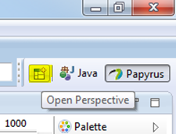 🡪 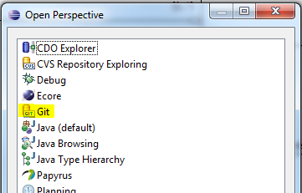

Figure 6‑3: Open Git Perspective

In the  window click on .

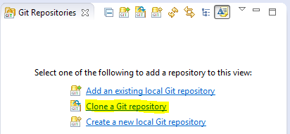

Figure 6‑4: Add Repository Choices

The URI of the repository is provided on the modeler’s GitHub space; see step 1.  
Copy this address (https://github.com/<modeler’s git user name>/EAGLE-Open-Model-Profile-and-Tools.git) into the URI field (the Host and Repository path fields are then automatically populated) and enter your GitHub username and password.

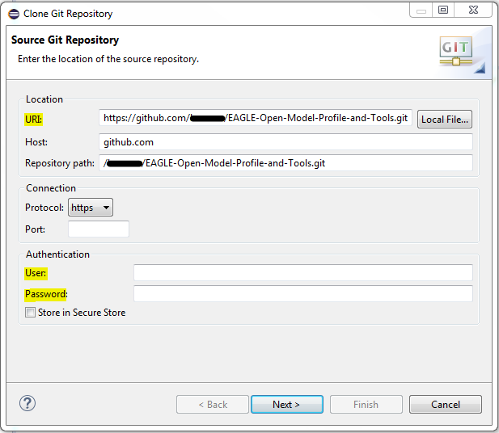

Figure 6‑5: Source Git Repository Window

Click  and select **only** the OpenModelProfile branch:

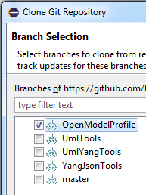

Click  and insert the destination directory on your local disk where you want the profile to be stored.

  should be checked.

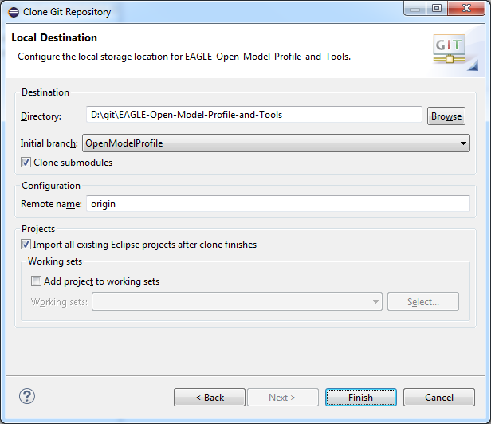

Figure 6‑6: Local Destination Window

Click . The OpenModelProfile is now downloaded to your local PC.

1. The  window should then contain the following files:

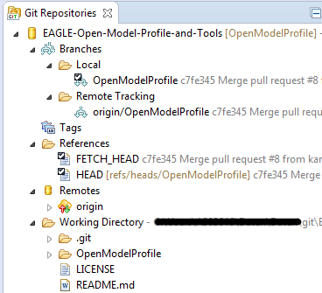

Figure 6‑7: OpenModelProfile Branch Cloned to Local PC

Since you have checked the  checkbox, the OpenModelProfile project automatically appear in the  window in the Papyrus perspective. You may double verify this at the perspective:  
  
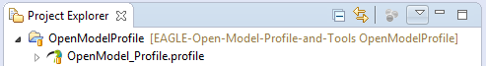

1. The following steps describe how to update the local OpenModelProfile files.  
   The latest version of the OpenModelProfile is stored in the EAGLE remote repository on GitHub. An additional pointer needs to be added to the list of remote branches.  
   This additional remote branch can be configured in the  window of the Git perspective. Right click on  and select Create Remote …:

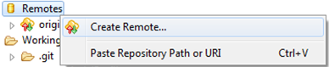

Enter a name for the remote branch and select :

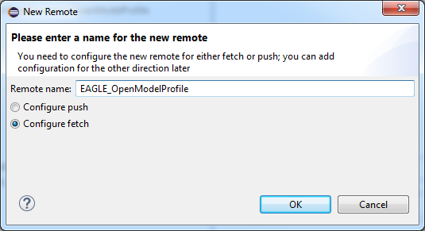

Figure 6‑8: Create Additional Remote (1)

Click .

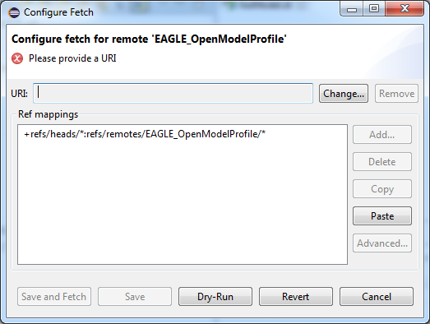

Figure 6‑9: Create Additional Remote (2)

Click  to enter the URI of the EAGLE repository   
(<https://github.com/OpenNetworkingFoundation/EAGLE-Open-Model-Profile-and-Tools.git>):

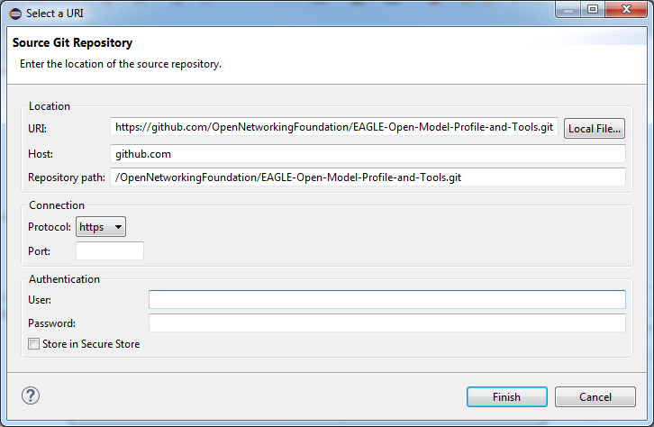

Figure 6‑10: Create Additional Remote (3)

Enter user name and password and click .  
Delete the existing item in the Configure Fetch window:  
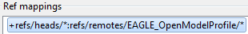  
Click then  in the Configure Fetch window. Enter a space in the Source field to get the list of the branches and select the :

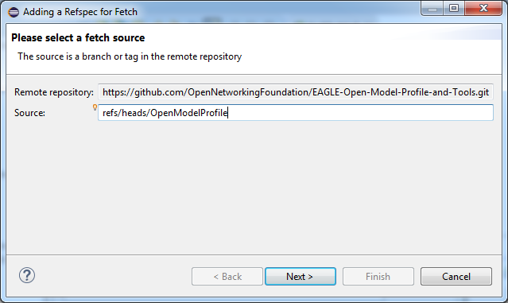

Figure 6‑11: Create Additional Remote (4)

Click  and then 

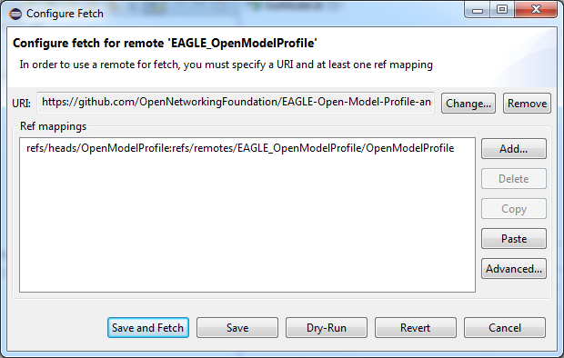

Figure 6‑12: Create Additional Remote (5)

Click .  
The additional branch is added to the Remotes list:  
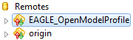

1. To align the OpenModelProfile version in the local repository with an updated version on GitHub you need to go to the  window of the Git perspective. Right click on  in the  list and select :  
   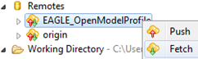

To be completed

1. Description of merge to be added
2. Description of push to be added

## Information Model on GitHub

Note:  
The following GitHub usage description is using XxxModel as a placeholder for any Paprus UML model.

The XxxModel is stored in a repository on GitHub. The link to the repository is {XxxModel}.

The model development architecture identifies two groups of people that are working with the model: (a) Modelers who do the actual writing of the model pieces, and (b) Administrators who establish the working environment and control the “master copy” of the XxxModel.

### XxxModel Structure on GitHub

The XxxModel is contained in a “master branch” on GitHub. A copy of this master branch is provided in the “develop branch”.



Figure 6‑13: Initial Model Structure on GitHub

The modeling teams are developing their part of the model in their develop branch. All updates of the individual develop branches will be merged back to the master branch from time to time[1].

## GitHub Work Flow

The following steps describe the work flow that a modeler has to follow when developing parts of the XxxModel.

Section 6.4 describes a more easy way of getting the XxxModel to the local PC. This way is restricted to “read only viewers” of the model since it does not allow to commit changes back to GitHub.

The steps correspond with the numbers  in Figure 6‑14.



Figure 6‑14: GitHub Work Flow

1. The administrator has established the Xxxodel repository (containing the master and develop branches) in the SDO git space under the following URL: {XxxModel}.
2. The modeler needs to copy the repository from the SDO git space into its own git space; by clicking on :  
     
   
3. An individual modeler works only in the develop branch. This specific branch needs to be copied to the modeler’s local PC into a local repository. This is done using the git client that is contained in the Eclipse tool on the local PC.

 Make sure that the Eclipse Workspace that is selected during launch of   
Eclipse does not contain already the XxxModel project.

Note:  
More than one version of the model can only be maintained on the local PC if they are in different Eclipse Workspaces.

After the Eclipse has been launched in the local PC, the git client can be started by clicking the “Open Perspective” button: and then choosing the  perspective.  
Note: Depending on the Eclipse version, the git client may have another name (including the term “Git”)[2].

 🡪 

Figure 6‑15: Open Git Perspective

In the  window click on .



Figure 6‑16: Add Repository Choices

Copy and paste the address that is provided on the web page of the XxxModel in the modeler’s git space:  
  


Figure 6‑17: Location of the Repository Address

Copy this address (https://github.com/<modeler’s git user name>/XxxModel.git) into the URI field (the Host and Repository path fields are then automatically populated) and enter your GitHub username and password.

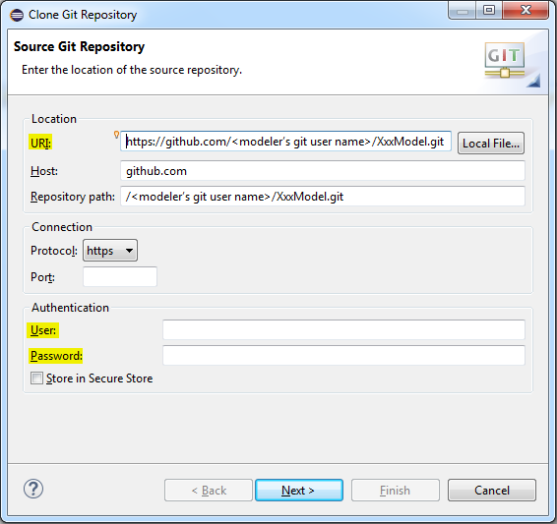

Figure 6‑18: Source Git Repository Window

Click  and select **only** the develop branch.

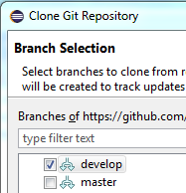

Figure 6‑19: Branch Selection Window

Click  and insert the destination directory on your local disk where you want the model to be stored.

  should be checked.

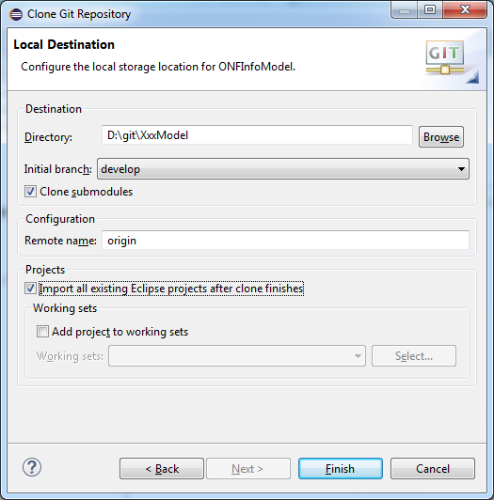

Figure 6‑20: Local Destination Window

Click . The selected branch of the XxxModel is now downloaded to your local PC.

1. Since you have checked the  checkbox, the XxxModel project should automatically appear in the  window in the Papyrus perspective. You may double verify this at the perspective:  
     
   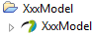.
2. A double-click on  starts the modeling in Papyrus and opens the XxxModel in the  window.

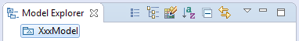

Figure 6‑21: XxxModel Shown in Papyrus Model Explorer

It may be necessary to import the common UML Primitive Types (i.e., Boolean, Integer, String). This can be done by a right-click on the model pacakge  then going to  /  and then select :

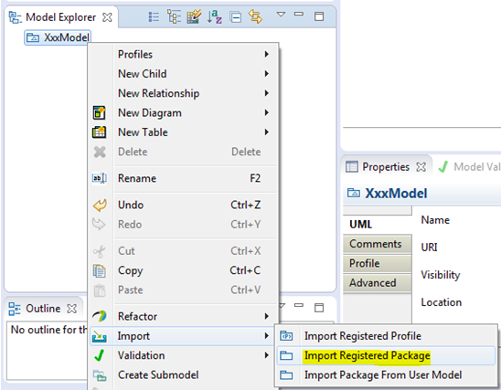 🡪 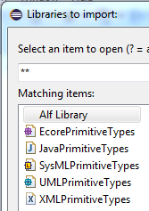

Figure 6‑22: Importing UML Primitive Types

It may also be necessary to relate artifacts in the sub-module to artifacts defined in the core model. This can be done by a right-click on the model package  then via  and  select  / :

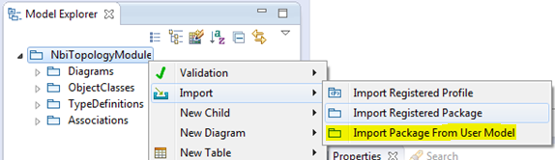  
  
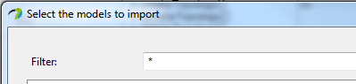  
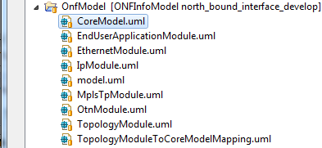

Figure 6‑23: Importing Core Model Artifacts

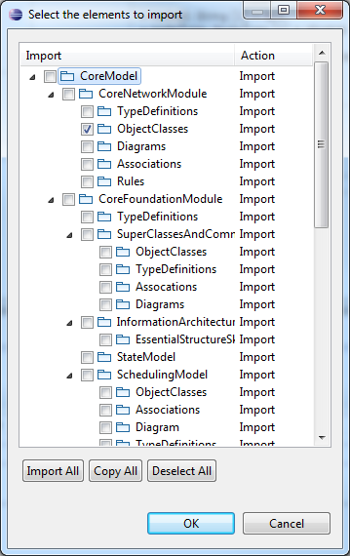

Figure 6‑24: Selecting Core Model Artifacts

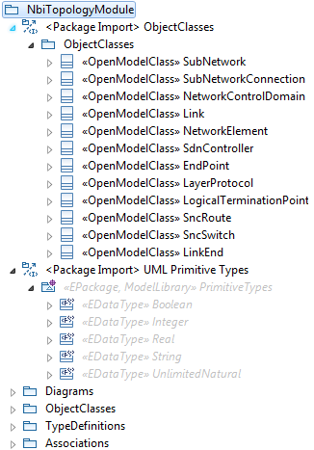

Figure 6‑25: Imported Core Model Artifacts

The designer of the XxxModel can now develop the model. The allowed actions are described in section 7.5.

Note: Papyrus “Save” updates only the local working Directory  
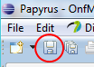.

1. After saving the changes in Papyrus the updated files are shown in  in the  perspective.

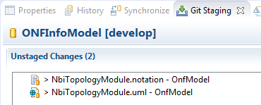

Figure 6‑26: Unstaged Changes in Git Staging

Select all TopologyModule files, right-click and select :

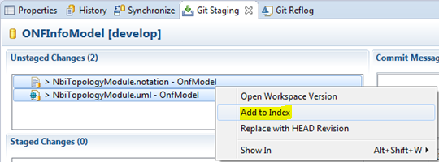

Figure 6‑27: Add Files to Git Stage

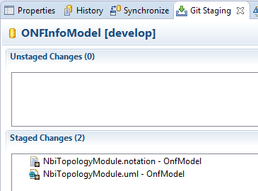

Figure 6‑28: Staged Changes in Git Staging

1. To commit the staged changes to your local repository you need to provide a commit message describing the changes that were done and then click on .
2. Steps 4 – 6 are all dealing only with changes on the local PC of the modeler. To save the changes to the modeler’s remote repository you need to right-click on the repository in the  tab and select .

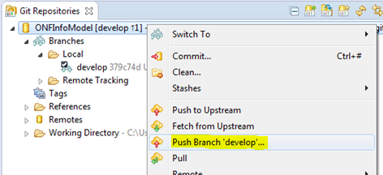

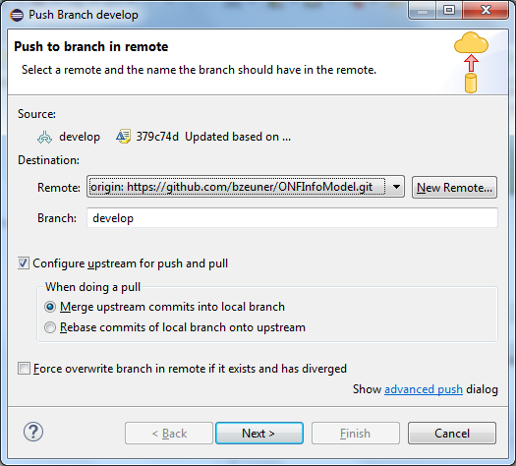

Figure 6‑29: Push Updated Branch to Remote Repository

Make sure you have checked  and .

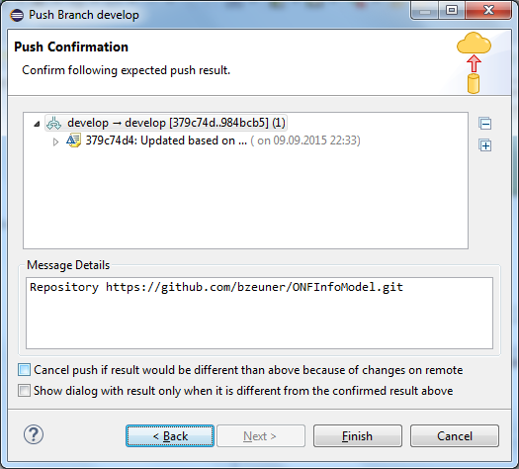

Figure 6‑30: Push Confirmation Window

Finally click .

1. Steps 3 – 7 can be done as often as necessary.  
   Once all updates of the sub-model for the next release of the ONF Information Model are finished, the modeler needs to notify the administrators that a stable version is ready. This is done by a pull request from the modeler’s remote repository using  or .

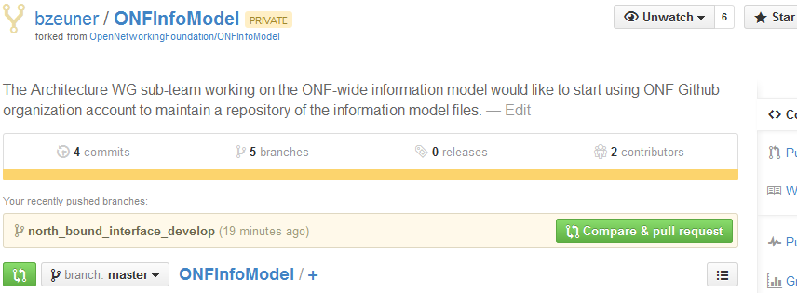

Figure 6‑31: Compare in Modeler’s Remote Repository

After click on  or  git provides a detailed comparison of all changes done in all files.

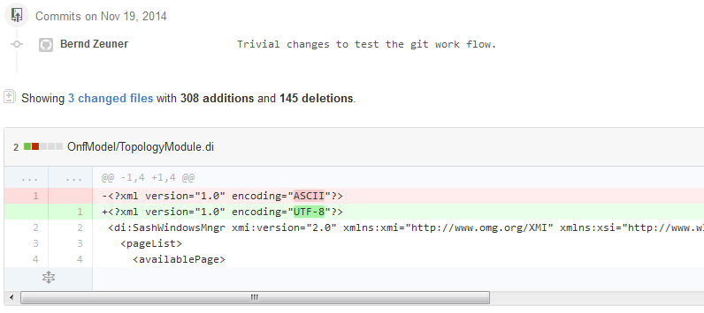

Figure 6‑32: Detailed Comparison in Modeler’s Remote Repository

The modeler can review the changes, add a comment to this updated version of the sub-model and then send the pull request by clicking on .

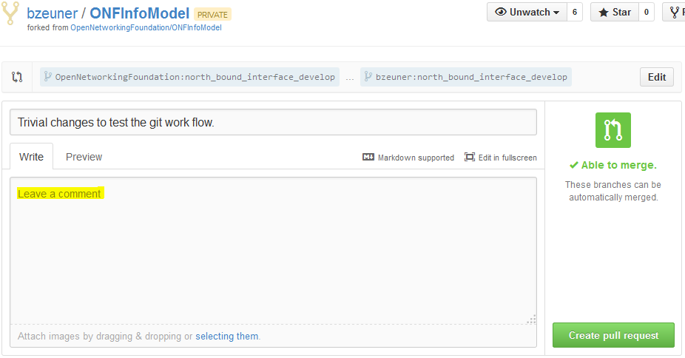

Figure 6‑33: Pull Request in Modeler’s Remote Repository

1. The administrator of the ONF remote repository receives the pull request and can merge the updates into its repository.

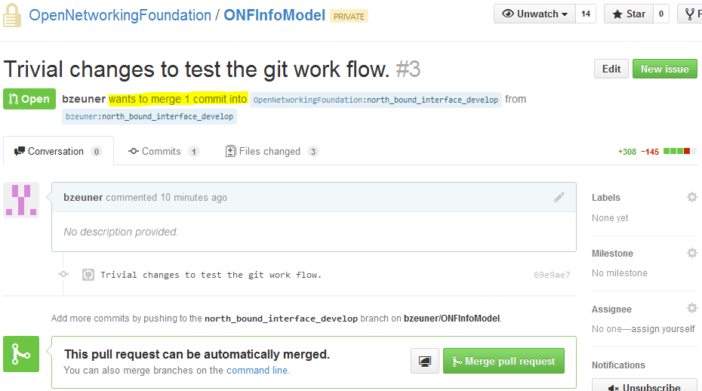

Figure 6‑34: Pull Request in Administrator’s Remote Repository

## Downloading a Model from github for “Read Only Use”

This section describes a more easy way of getting the XxxModel to the local PC. This way is restricted to “read only viewers” of the model since it does not allow to commit changes back to GitHub.

1. The XxxModel repository is located in the SDO git space under the following URL: {XxxModel}.
2. Click the  button of the github web page to download the repository to your local PC.



Figure 6‑35: Download XxxModel Repository

1. Extract the zip-file to the desired Eclipse Workspace.
2. Make the XxxModel visible in the Papyrus Project Explorer by importing the model and profile projects.  
   Right click in the  area opens the menu containing the -button:

 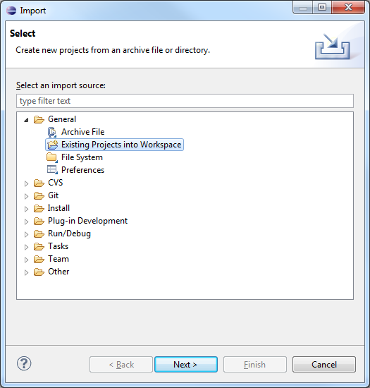

Figure 6‑36: Making the XxxModel visible in Papyrus (1)

You need to select the  option since the downloaded repository contains already the  files for the model and profile.

Click  and then point via  to the folder in your workspace containing the extracted repository files from step 2.

The XxxModel is already selected in the Projects box.

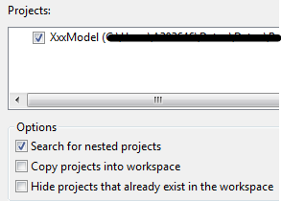

Figure 6‑37: Making the XxxModel visible in Papyrus (2)

Do not select the option  since the files are already in your workspace.

Click .

# Using Papyrus

## Illustrative Profile and Model

This guideline document uses an illustrative UML profile and an illustrative core-model and sub-model to explain the handling of Papyrus.

UML artifacts are defined by their properties (i.e., a kind of Meta Model). Standard properties are defined by the UML Specification [3] which are usually already supported by the UML tool (e.g., Papyrus). Additional specific properties are defined in a UML Profile (model).  
The UML Guidelines document [4] describes the additional properties in detail.

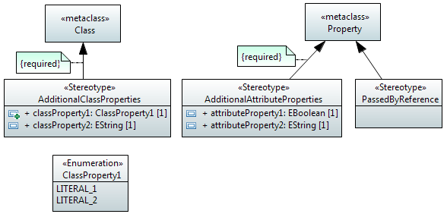

Figure 7‑1: Illustrative UML Profile

The AdditionalClassProperties stereotype adds properties classProperty1 and classProperty2 to the object classes in the model. The extension relationship has been defined as “required” which adds the additional properties to all object classes; i.e., for every class created, the AdditionalClassProperties stereotype will be present by default.

The AdditionalAttributeProperties stereotype adds properties attributeProperty1 and attributeProperty2 to the attributes in the model. The extension relationship has been defined as “required”, which adds the additional properties to all attributes; i.e., for every attribute created, the AdditionalAttributeProperties stereotype will be present by default.

The PassedByReference stereotype identifies an attribute or an operation parameter being passed by value or passed by reference. The extension relationship has not been defined as “required”, which means that the stereotype has to be associated to the attribute on a case by case basis.  
Note:  
Only those attributes and operation parameters that refer to object classes may have the PassedByReference stereotype.

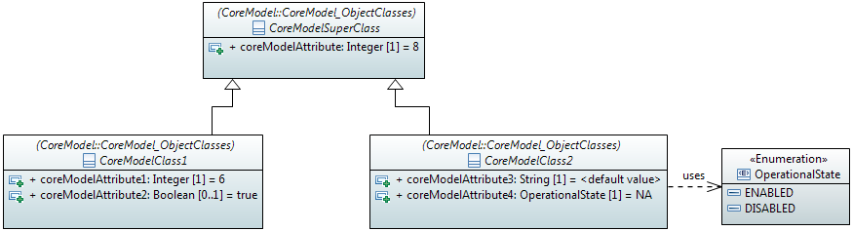

Figure 7‑2: Illustrative Core Model

The initial core model contains a super-class and two sub-classes.

The profile from Figure 7.1 is associated to the model. This adds the additional properties to the artifacts in the model or allows their use in the model respectively.

You can check if a profile is associated to the model (and which one) by clicking on  inside the  and then click the  tab of the  tab.

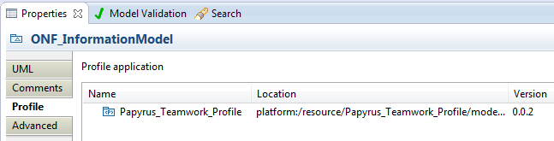

Figure 7‑3: Profile Associated to the Model

## Papyrus File Structure

A Papyrus model is stored in three different files (.di, .notation, .uml):

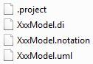 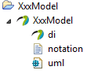

(Structure on the file system (left side); structure in the Papyrus Project Explorer (right side))

Figure 7‑4: Papyrus File Structure

As already mentioned in section 5.3, a model cannot exist on its own in Papyrus. It has to be contained by a “project”. A project can contain many models (i.e., multiple sets of .di, .notation, .uml files, as shown in Figure 7.5 below). The .project file contains the information about the project.

## Model Splitting

Papyrus is able to split a UML model into different pieces (i.e., different files) allowing various teams to develop the model in a collaborative manner. The model pieces can be edited independently of the core model and then be re-merged with the core model.

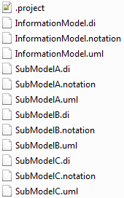 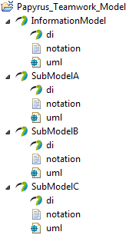

(Structure on the file system (left side); structure in the Papyrus Project Explorer (right side))

Figure 7‑5: Papyrus File Structure after Splitting

Each sub-model designer will be provided with all profile and model files to allow a comprehensive view (including cross-associations) on the Information Model at a given time of specification. Only the own sub-model files (.di, .notation, .uml) are writeable; all other files are write protected.

 Write protected files must not be changed.   
Changes in the other parts of the model are only allowed by the respective model designer.

The sub-model designer must be able to relate the sub-model object classes to the core object classes and to use the data types defined in the core-model.  
This is enabled by importing the core-model object classes and core-model type definitions into the sub-model. The common UML Primitive Types (i.e., Boolean, Integer, String) also need to be imported. Section 6.2 (step 4) explains how to import additional artefacts.

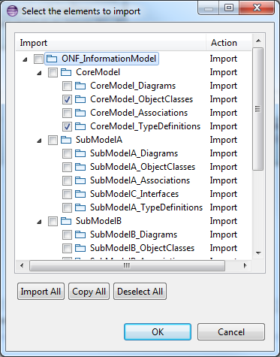 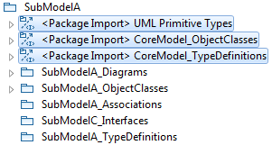

Figure 7‑6: Imported UML Artifacts

Note:  
In case one sub-model needs to refer to object classes or type definitions from another sub-model, these artifacts also need to be imported into the sub-model. In case such a definition is used in more than one other sub-model, the definition should be “elevated” to the core-model.

## Team UML Model Development

The Information Model is developed by different teams. An “interSDO Modeling team” is responsible for the core-model /OpenModelProfile and SDO-specific teams for each sub-model.

The “interSDO Modeling team” is also responsible for the organization of the whole modeling work. It provides the basic model files for each sub-model team and merges the sub-models back to the overall Information Model.

The IMP Modeling team creates a zip-file per sub-model team (e.g., sub-model A) which contains the OpenModel Profile, the core-model and all existing/planned sub-models at that time. Only the specific sub-model files of sub-model A are writeable (highlighted in green in Figure 7.7), all other files are write protected.



Figure 7‑7: Information Model File Structure

The sub-model designer imports the Open Model Profile (here Papyrus_Teamwork_Profile) into the workspace via  :

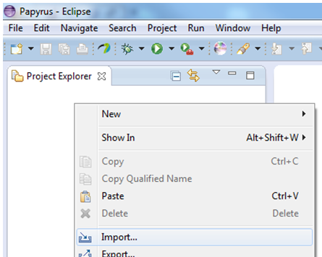 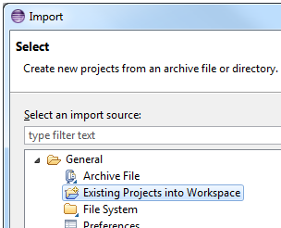

Figure 7‑8: Importing an Existing Project into Papyrus

After importing the Profile, the sub-model designer imports the ONF Information Model (here Papyrus_Teamwork_Model) into the workspace via .

 The Profile must be imported **before** the Information Model.   
 Otherwise, the Profile is not associated to the Model.

  
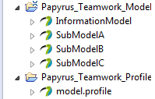  
  
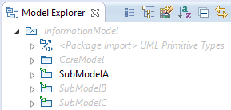

Figure 7‑9: Project and Model Explorer View after Import into Papyrus

The  shows the CoreModel, SubModelB and SubModelC in grey because these models are write protected.

The sub-model A designer can now develop the model.

 Sub-Model A designer **must** select the core model in the .   
 I.e., double click on “InformationModel”; **not** “SubModelA”.

The core-model must be selected after every saving of the model.



Figure 7‑10: Modeling Process over Time

## Developing a Sub-Model

The designer of the sub-model can now develop the model:

* Creating object classes
* Setting additional properties (defined in the Profile) of the object classes
* Adding attributes to object classes
* Setting additional properties (defined in the Profile) of the attributes
* Using data types defined in the core-model
* Inheriting sub-model object classes from core-model object classes
* Creating associations from sub-model object classes to core-model object classes
* …

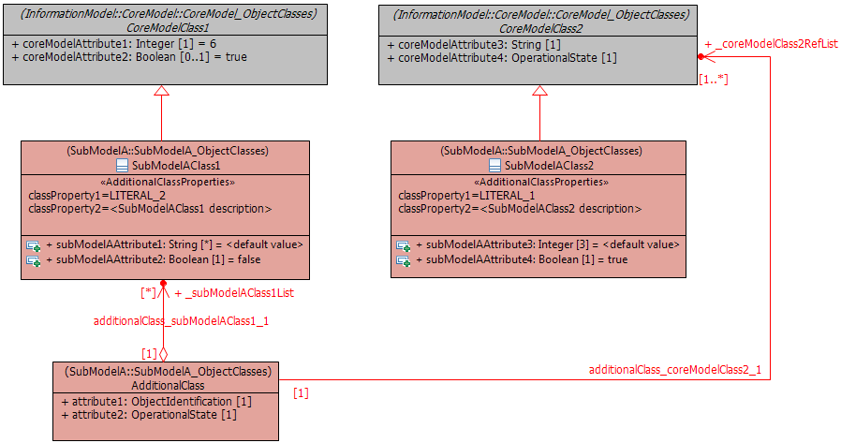

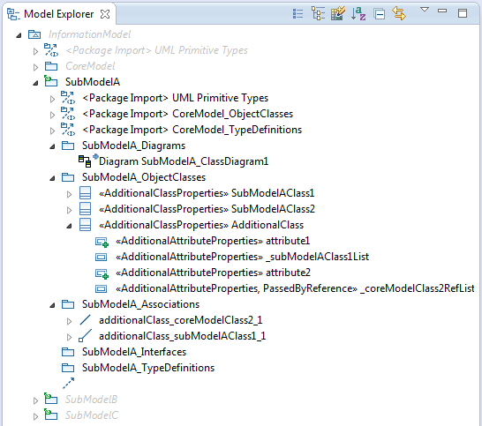

Figure 7‑11: Example Sub-Model A (highlighted in red)

Note: The stereotypes in front of the class/attribute names (red boxes) indicate that the class/attribute has the additional properties illustrated in Figure 7.1.

The development of sub-model A is stored in the .uml and .notation files; i.e., these are the only files that are updated:

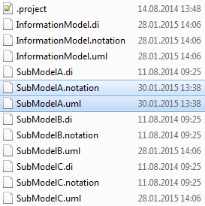

Figure 7‑12: Updated Sub-Model A Files (highlighted in blue)

The ONF Information Model team takes these two files and overwrites the corresponding files in the original model workspace. The updated individual sub-models can now be “re-integrated” into the single ONF Information Model.

Notes:

After re-opening the model in the original model workspace, the data types (imported from the core-model) are automatically related to the core-model data types and the core-model classes used in the sub-model class diagrams are automatically related to the corresponding classes in the core-model.

Adding new data types to the type definitions in the core-model automatically adds them also to the imported type definitions in the sub-model.

# Extracting Data from a Papyrus model

This section describes how to extract diagrams, comments and details for a Data Dictionary from a Papyrus model. There are two ways of extracting information from a Papyrus model:

* Using the Gendoc plugin
  + Recommended method for document generation
  + Provides a Microsoft Word document
  + Enables extraction of diagrams as well as model content such as classes, comments etc
* Using the Table function from Papyrus
  + Alternative method for extracting model content into a table form
  + Provides a basic format

## Gendoc Plugin

The Gendoc plugin is used in conjunction with a document template. The template contains instructions that enable generation of a Microsoft Word document. The document can include extracts from the model such as diagrams, class definitions, attribute definitions along with their stereotypes etc as well as figures and text directly entered into the template. This section provides instructions on how to install Gendoc followed by guidance on construction of Gendoc templates along with example fragments of templates.

## Installing Gendoc

Click menu  and then :

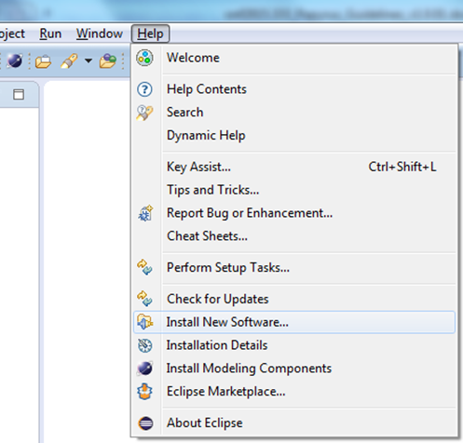

Figure 8‑1: Installing Gendoc (1)

Click  and enter the Gendoc 0.5.0 update site:  
<http://download.eclipse.org/gendoc/updates/releases/0.5.0/>

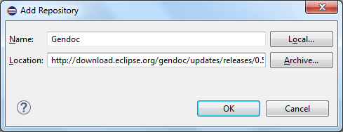

Figure 8‑2: Installing Gendoc (2)

Select Gendoc:

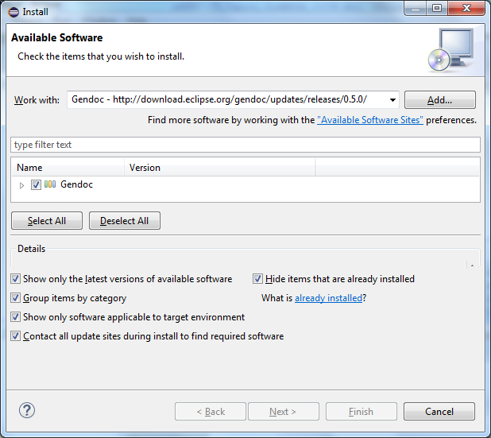

Figure 8‑3: Installing Gendoc (3)

Then click  and follow the instructions.

## Using Gendoc

Annex A describes how to use Gendoc.

## Papyrus Table

Unlike the class diagrams which show only parts of the underlying model, a Data Dictionary contains all of the information stored in the model. Papyrus provides a function to convert the content of the model into an Excel sheet.

  


Double Click Here

Figure 8‑4: Model Selection

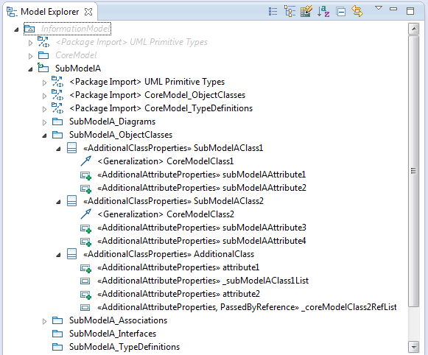

Expand all classes

Figure 8‑5: Class Expansion

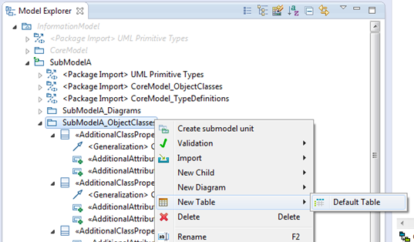

Right Click here

Figure 8‑6: Create new empty Table

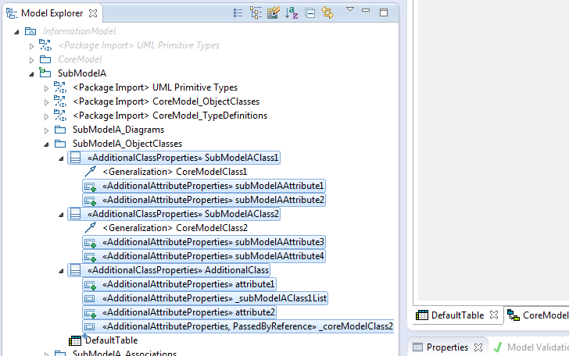

Drag the highlighted things here

Highlight the classes and attributes you want to put in the table

Figure 8‑7: Artifact Selection

The content of the new table can be converted into an Excel sheet by selecting the required columns in the table and then copy&paste the data into an Excel sheet.

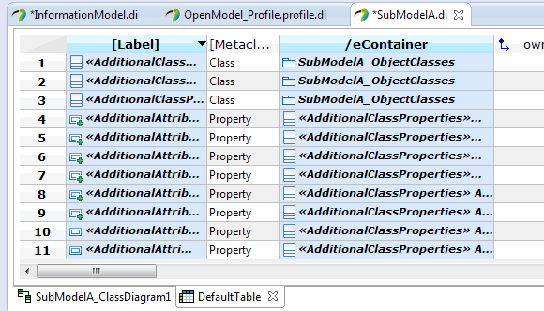

Figure 8‑8: Creation of Excel Sheet (1)

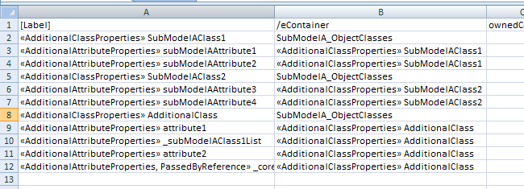

Figure 8‑9: Creation of Excel Sheet (2)

# Importing RSA Models into Papyrus

This section describes the steps to be followed when Models “written” in RSA (TM Forum and ITU-T are using this UML tool from IBM) need to be imported to Papyrus.

Prerequisite for doing this is that the additional Papyrus component “RSA Model Importer” is installed. Additional Papyrus components can be installed via

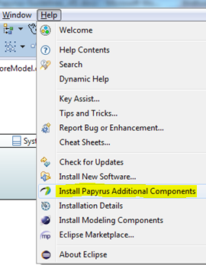 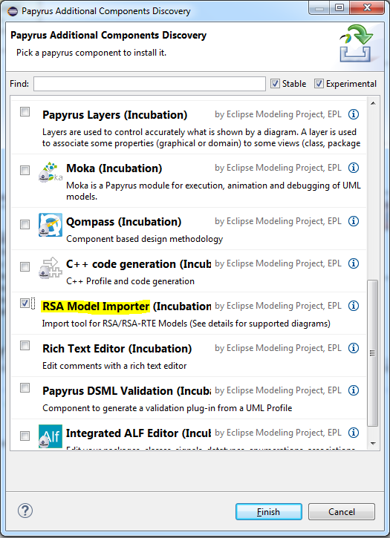

Figure 9‑1: Installing Papyrus Component “RSA Model Importer”

## Import RSA Model into Papyrus

Notes: Each step identifies the tool that is used to execute it. Any ASCII editor can be used instead of Notepad++.  
The import of the ITU-T G.8052 model is used here as an example.

1. Create a new, empty general project (i.e., not a Papyrus project).  
   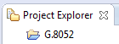
2. Copy the RSA .epx (profile) and .emx (model) files into the empty project folder.  
   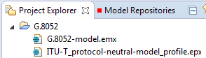
3. Import the RSA model (.emx file) into Papyrus by right-click on the .emx file and then select “Import EMX model”:

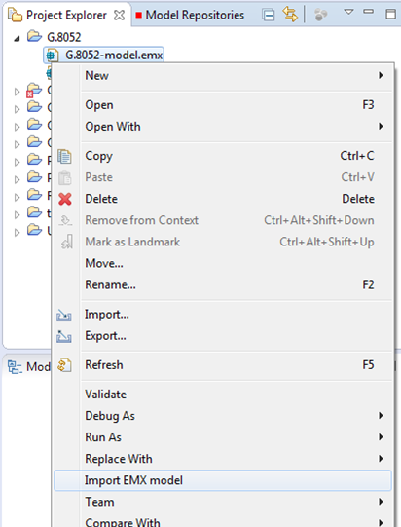

Figure 9‑2: : Importing .emx Model

As a result, the RSA .emx file is replaced by the Papyrus model file:  
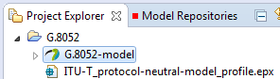

1. Import the RSA Profile model (.epx file) into Papyrus by right-click on the .epx file and then select “Import EMX model” (same as previous step).  
   As a result, the Papyrus profile model file is created:  
   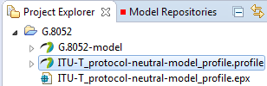

## Replace RSA Profile by Papyrus Profile

This is done by changing the pointer from the .epx (RSA) file to the .uml (Payprus) file.

1. Close Papyrus.  
   Notepad ++: Replace all occurrences of “ITU-T_protocol-neutral-model_profile.epx” by “ITU-T_protocol-neutral-model_profile.profile.uml” in the model .uml file () in the Papyrus Workspace:  
     
   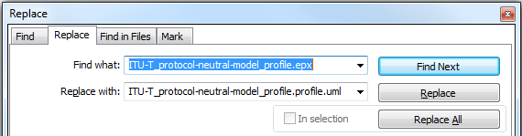

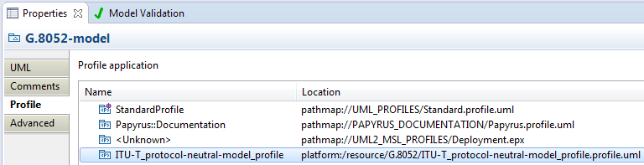

Figure 9‑3: Associated Papyrus Profile

## Remove the “old” RSA files

1. Windows Explorer: Delete the RSA profile .epx file () from the Papyrus Workspace.
2. Windows Explorer: Delete the RSA model .emx file () from the Papyrus Workspace.

###### Using Gendoc

Editor’s notes:  
This section is still a draft and will likely be changed in future versions.  
Please check the known issues in section for any limitation which exists at the time.

A basic document generation tutorial is available at  
<https://www.eclipse.org/gendoc/documentation/Gendoc_v0.5_tutorial.pdf>. This provides detail in some areas but does not cover all aspects of usage. The following subsections provide further guidance along with template fragments to assist understanding. A template that generates a normal form of model documentation is included for a dummy model.

Gendoc works with Microsoft Word and the template is a Word file. The template can a mix of Gendoc script, normal text, Word figures, tables etc. Thus, if you want to create a word document with other non-model related information, but then have a section specifically for the model, you would insert the “gendoc” related information as part of that Word document. The following section builds up a template from the basic framing script through to a full template. The target document resulting from the gendoc template:

* Is produced in a form that can be published having all the necessary cover material, table of contents, headers, footers etc
* Contains specific figures extracted from the model in a specific with additional interleaved description and word figures
* Contains a data dictionary section

The template described does not:

* Take advantage of the package structure of the model
* Interleave class description text with figures
  + Instead the figures refer to the data dictionary section for formal description and structure

It should be noted that at the time of writing this section there are a number of know issues with Gendoc (highlighted at the end of this section).

Template usage

The template is stored in a system folder accessible via an Eclipse project so that the template can be seen in the Papyrus Project Explorer. The folder could be a sub-folder of the system folder containing the project that includes the model to be documented. Alternatively the template can be stored in a specific project that just includes the template. The template “points” to the model to be extracted via the <context model> statement. The template is highlighted with the right-click menu and the “Generate documentation using Gendoc” item is selected. This will run the template, i.e. Gendoc is initiated from the template NOT from the model.

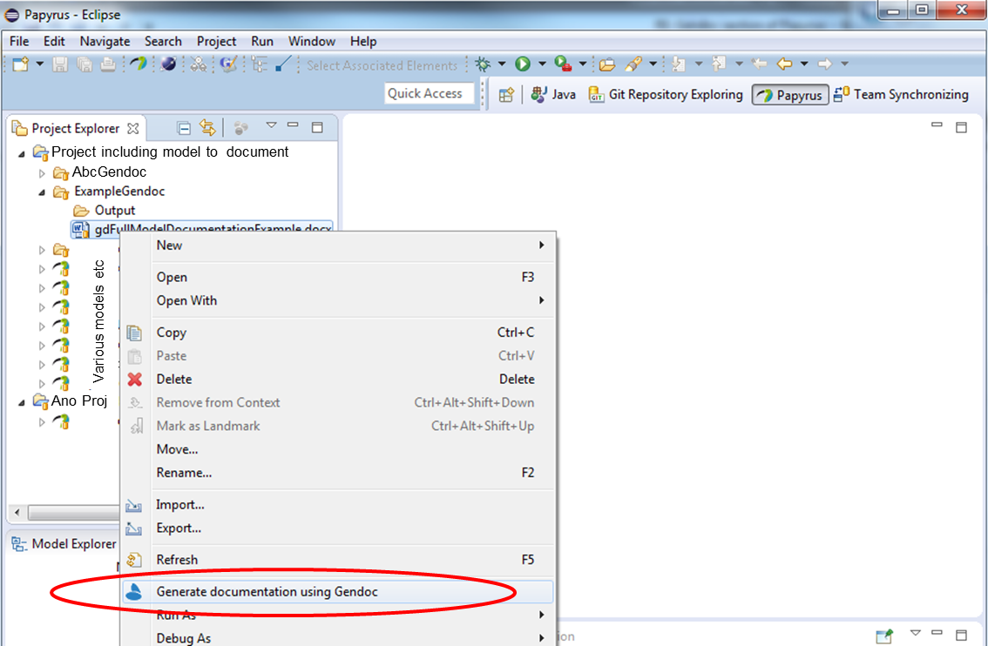

Figure A‑1: Initiating Gendoc for a particular template

The following section explain how the template is targeted at the desired model.

Basic template

The template includes the name of the model to be documented and the name of the target model (substitute path and model name in the structure below). Both the .uml and .notation files are required.[3]

<config>  
<output path=’C:\Users\---appropriate path name--\ModelOutput.docx' />

</config>

<context model=’C:\Users\---appropriate path name--\ModelName.notation' element=’{0}’ importedBundles='gmf;papyrus' />

<gendoc><drop/>

Provides access to diagrams

</gendoc><drop/>

<context model=’C:\Users\---appropriate path name--\ModelName.uml' element=’{0}’ importedBundles='gmf;papyrus' />

<gendoc><drop/>

Provides access to class details

</gendoc><drop/>

This particular template produces a document with the two black text items only. In the above example, the entire model “ModelName.uml” is taken as input. In order to select only one package in the model, one would set “element=’ModelName/{package name}’”.

Cover, contents, closing text etc

Any text and figures[4] inserted between the <gendoc> to </gendoc> space will be produced in the output.

<gendoc><drop/>

Any text and diagrams etc…

</gendoc><drop/>

Figures from the model with interleaved text

The figures can be extracted in alphabetical order from the model. The following script (in bold) will print the figure titles from the model in alphabetical order.

<config>  
<output path=’C:\Users\---appropriate path name--\ModelOutput.docx' />

</config>

<context model=’C:\Users\---appropriate path name--\ModelName.notation' element=’{0}’ importedBundles='gmf;papyrus' />

<gendoc><drop/>

**[for (d : notation::Diagram |notation::Diagram.allInstances()->sortedBy(name))]<drop/>**

**[d.name/]**

**[/for]<drop/>**

</gendoc><drop/>

Clearly this by itself is not particularly useful but substituting the “[d.name/]” with the following bold script and replacing “specificDiagramName“ with the name (or unique substring of a name) of a diagram in the model will extract a specific named diagram (printing the diagram and its name)[5].

<gendoc><drop/>

**Text** **and figures leading to diagram …**

[for (d : notation::Diagram |notation::Diagram.allInstances()->sortedBy(name))]<drop/>

**[if d.name.contains('specificDiagramName')] [d.name/]**

**<drop/>**

**<image object='[d.getDiagram()/]' maxW='true' keepH='false' keepW=’false’></image>**

Figure 1 [d.name/]

**[else]<drop/>**

**[/if]<drop/>**

[/for]<drop/>

**More text and figures after diagram ….**

</gendoc><drop/>

The yellow area highlights a frame (which is otherwise not obvious). This frame is where Gendoc will place the figure. The frame will need to be sized to the right width in an actual usage (shrunk here to reduce space used in this document). The script will allow Gendoc to adjust the height but forces it to not exceed maximum width.

The following template extract expands for two figures (and could clearly be expanded to cover many more.

<gendoc><drop/>

**Text** **and figures leading to diagram …**

[for (d : notation::Diagram |notation::Diagram.allInstances()->sortedBy(name))]<drop/>

**[if d.name.contains('specificDiagramName')] [d.name/]**

**<drop/>**

**<image object='[d.getDiagram()/]' maxW='true' keepH='false' keepW=’false’></image>**

Figure 1 [d.name/]

**[else]<drop/>**

**[/if]<drop/>**

[/for]<drop/>

**More text and figures after diagram and leading to the second diagram**

[for (d : notation::Diagram |notation::Diagram.allInstances()->sortedBy(name))]<drop/>

**[if d.name.contains('anotherSpecificDiagramName')] [d.name/]**

**<drop/>**

**<image object='[d.getDiagram()/]' maxW='true' keepH='false' keepW=’false’></image>**

Figure 2 [d.name/]

**[else]<drop/>**

**[/if]<drop/>**

[/for]<drop/>

**More text and figures after diagram ….**

</gendoc><drop/>

The model may have many figures, the remainder will be ignored. Clearly care needs to be taken to ensure that one figure does not have a name string that is a sub-string of another name.

Figure in alphabetical order with no interleaved specific text

Alternatively the simple loop can be used to list all figures in alphabetical order. These cannot have associated document text inserted automatically.

<config>  
<output path=’C:\Users\---appropriate path name--\ModelOutput.docx' />

</config>

<context model=’C:\Users\---appropriate path name--\ModelName.notation' element=’{0}’ importedBundles='gmf;papyrus' />

<gendoc><drop/>

**[for (d : notation::Diagram |notation::Diagram.allInstances()->sortedBy(name))]<drop/>**

**[d.name/]**

**<image object='[d.getDiagram()/]' maxW='true' keepH='false' keepW=’false’></image>**

Figure 1 [d.name/]

**[/for]<drop/>**

</gendoc><drop/>

Further explanation of the script

A majority of the script used in the previous sections should be relatively obvious (e.g. [for…]… [/for] loop and [if…]… [else]… [/if] nested structures. The specific contents of the for and if statements is covered adequately in the tutorial material referenced earlier. One key thing to highlight here is the use of <drop/>. This instruction causes Gendoc to not throw a line break for the line that has <drop/>. You may find many blank lines in your output. This will normally be because you have forgotten one or more <drop/> instructions.

There is a peculiar behavior with diagrams that requires a <drop/> on the blank line prior to the <image…> command. Without this part (but not all) of the <image… > instruction is printed.

Test template for printing diagrams and associated text

The following embedded file contains script which when modified to select the right model (several places in the file) and output locations will print three diagrams from the model.



Data Dictionary template overview

In the following subsections the template is extended to add data dictionary content. This particular example data dictionary includes Classes and Data Types along with their attributes and for each provides (as appropriate):

* Comments
* Properties
* Stereotypes

Note that the stereotypes examples are from the OpenModelProfile [7].

Adding the class and its stereotypes

Considering the basic template described above and replacing the text “Provides access to class details” with the section in bold below will provide the class name, class comments comments and the class stereotypes

<config>  
<output path=’C:\Users\---appropriate path name--\ModelOutput.docx' />

</config>

<context model=’C:\Users\---appropriate path name--\ModelName.notation' element=’{0}’ importedBundles='gmf;papyrus' />

<gendoc><drop/>

Provides access to diagrams

</gendoc><drop/>

<context model=’C:\Users\---appropriate path name--\ModelName.uml' element=’{0}’ importedBundles='gmf;papyrus' />

<gendoc><drop/>

**[for (cl:Class | Class.allInstances()->sortedBy(name))]<drop/>**

**[cl.name/]**

**[for (co:Comment | cl.ownedComment)]<drop/>**

**<dropEmpty>[co._body.clean()/]</dropEmpty>**

**[/for]<drop/>**

**Applied stereotypes:**

**[for (st:Stereotype | cl.getAppliedStereotypes())]<drop/>**

* **[st.name/]**

**[for (oa:Property|st.ownedAttribute)]<drop/>**

* **[if (not oa.name.contains('base'))][oa.name/]: [if (not cl.getValue(st, oa.name).oclIsUndefined())][if oa.name.contains('condition')][cl.getValue(st, oa.name).oclAsType(String)/] [else][cl.getValue(st, oa.name).oclAsType(EnumerationLiteral).name/][/if][else]<drop/>[/if]**

**[/if] <drop/>**

**[/for]<drop/>**

**[/for]<drop/>**

**[/for]<drop/>**

</gendoc><drop/>

Note that:

* The classes are in alphabetical order
* The comment body is not printed if empty using the <dropEmpty>..</dropEmpty> instruction
* Any properties of stereotypes that have “base” in their name are not printed
* “conditions” are only printed if there is a specified condition
* The [cl.name/] would be expected to be a heading in a normal document

Adding properties and stereotypes in tabular form

The script from the previous section has been extended with the additional script highlighted below in bold (other than the table contents). The table produced by the script here includes an explicit structuring of the stereotypes.

<config>  
<output path=’C:\Users\---appropriate path name--\ModelOutput.docx' />

</config>

<context model=’C:\Users\---appropriate path name--\ModelName.notation' element=’{0}’ importedBundles='gmf;papyrus' />

<gendoc><drop/>

Provides access to diagrams

</gendoc><drop/>

<context model=’C:\Users\---appropriate path name--\ModelName.uml' element=’{0}’ importedBundles='gmf;papyrus' />

<gendoc><drop/>

[for (cl:Class | Class.allInstances()->sortedBy(name))]<drop/>

[cl.name/]

[for (co:Comment | cl.ownedComment)]<drop/>

<dropEmpty>[co._body.clean()/]</dropEmpty>

[/for]<drop/>

Applied stereotypes:

[for (st:Stereotype | cl.getAppliedStereotypes())]<drop/>

* [st.name/]

[for (oa:Property|st.ownedAttribute)]<drop/>

* [if (not oa.name.contains('base'))][oa.name/]: [if (not cl.getValue(st, oa.name).oclIsUndefined())][if oa.name.contains('condition')][cl.getValue(st, oa.name).oclAsType(String)/] [else][cl.getValue(st, oa.name).oclAsType(EnumerationLiteral).name/][/if][else]<drop/>[/if]

[/if] <drop/>

[/for]<drop/>

[/for]<drop/>

**[if cl.ownedAttribute->notEmpty()]<drop/>**

**Table 1: Attributes for [cl.name/]**

**<drop/>**

**<table><drop/>**

|  |  |  |  |  |  |
| --- | --- | --- | --- | --- | --- |
| **Attribute Name** | **Type** | **Multiplicity** | **Access** | **Stereotypes** | **Description** |

**[for (p:Property|cl.ownedAttribute)]<drop/>**

|  |  |  |  |  |  |
| --- | --- | --- | --- | --- | --- |
| **[p.name/]** | **[p.type.name/]** | **[if(p.lower=p.upper)]1[else][p.lower/]..[if(p.upper=-1)]*[else][p.upper/][/if][/if]** | **[if(not(p.isReadOnly))]RW[else]R[/if]** | **[for (st:Stereotype | p.getAppliedStereotypes())]<drop/>**  **[st.name/]**  **[for(oa:Property|st.ownedAttribute)]<drop/>**   * **[if oa.name.contains('attribute')]AVC: [p.getValue(st, oa.name).oclAsType(EnumerationLiteral).name/]**   **[else]<drop/>**   * **[if oa.name.contains('invariant')]isInvariant: [p.getValue(st, oa.name).oclAsType(Boolean)/]**   **[else]<drop/>**   * **[if oa.name.contains('value')]valueRange: [if (not p.getValue(st, oa.name).oclIsUndefined())][p.getValue(st, oa.name).oclAsType(String)/][else] no range constraint [/if]**   **[else]<drop/>**   * **[if oa.name.contains('support')]support: [p.getValue(st, oa.name).oclAsType(EnumerationLiteral).name/]**   **[else]<drop/>**   * **[if oa.name.contains('condition')][if (not p.getValue(st, oa.name).oclIsUndefined())]condition:[p.getValue(st, oa.name).oclAsType(String)/][else] <drop/> [/if]**   **[else]<drop/>**  **[/if]<drop/>**  **[/if]<drop/>**  **[/if]<drop/>**  **[/if]<drop/>**  **[/if]<drop/>**  **[/for]<drop/>**  **[/for]<drop/>** | **[for (c:Comment | p.ownedComment)] <drop/>**  **[c._body.clean()/]**  **[/for]** |

**[/for]<drop/>**

**</table><drop/>**

**[else][/if]<drop/>**

[/for]<drop/>

</gendoc><drop/>

Note that this and following sections have been reoriented to landscape as is advisable in a document when producing attribute data dictionary content.

Adding complex data types

A complex data types have a very similar structure to a class and hence the Gendoc commands are similar. The following snippet highlights in bold the differences between the class script above and the data type script replacing from “[for (cl:Class | Class.allInstances()->sortedBy(name))]<drop/>”

[for **(dt:DataType | DataType.**allInstances()->sortedBy(name))]<drop/>

[if **dt.**oclIsTypeOf**(DataType)**]<drop/>

[**dt**.name/]

[for (co:Comment | **dt.**ownedComment)]<drop/>

<dropEmpty>[co._body.clean()/]</dropEmpty>

[/for]<drop/>

Applied Stereotypes:

**[for (st:Stereotype | dt.getAppliedStereotypes())]<drop/>**

* **[st.name/]**

**[/for]<drop/>**

[if **dt**.ownedAttribute->notEmpty()]<drop/>

Table 2: Attributes for [dt.name/]

<drop/>

<table><drop/>

|  |  |  |  |  |  |
| --- | --- | --- | --- | --- | --- |
| **Attribute Name** | **Type** | **Multiplicity** | **Access** | **Stereotypes** | **Description** |

[for (p:Property|dt.ownedAttribute)]<drop/>

…… then the table is the same as for the class attributes…

Adding other data types

Enumeration Types

The following script will extract all enumerations with their comments and list the literals with their comments for each. Clearly stereotypes can be extracted using fragments of script from earlier sections.

[for (dt:DataType | DataType.allInstances()->sortedBy(name))]<drop/>

[if dt.oclIsTypeOf(Enumeration)]<drop/>

[dt.name/]

[for (co:Comment | dt.ownedComment)]<drop/>

<dropEmpty>[co._body.clean()/]</dropEmpty>

[/for]<drop/>

Contains Enumeration Literals:

[for (e:EnumerationLiteral|dt.oclAsType(Enumeration).ownedLiteral)]<drop/>

* [e.name/]:
  + [for (co:Comment | e.ownedComment)]<drop/>
  + <dropEmpty>[co._body.clean()/]
  + </dropEmpty>[/for]<drop/>

[/for]<drop/>

[else] [/if]<drop/>

[/for]<drop/>

Primitive Types

Primitive types can be listed with comments using the followings script.

[for (dt:DataType | DataType.allInstances()->sortedBy(name))]<drop/>

[if dt.oclIsTypeOf(PrimitiveType)]<drop/>

[dt.name/]

[for (co:Comment | dt.ownedComment)]<drop/>

<dropEmpty>[co._body.clean()/]</dropEmpty>

[/for]<drop/>

[else] [/if]<drop/>

[/for]<drop/>

Example complete template

The following embedded file contains script which when modified to select the right model (several places in the file) and output locations will print three diagrams and/or all diagrams in the model (follow instruction to control the options) and will then provide data dictionary sections listing classes, complex data types, enumerations and primitive data types.



Note that when using a template figure numbers, table numbers, references, tables of contents/figures/tables etc will need to be updated in the output document to provide a completed document.

Extending the template

Work is ongoing to extend the capability for documentation. These guidelines will be updated as additional relevant capabilities are identified.

Known issues

Known issues:

* Some header/footer content may prevent document production
* “[“ (often used in references) must not be used in the Word text anywhere
* HTML formatting must not be used in a comment/description field for any artefact in a UML model

1. Driven by overall delivery schedule and coordinated by the administrators.
2. It is vital that all modelers use the same version of Papyrus to prevent compatibility issues.
3. It is expected that the .notation file will eventually not be necessary and intertwining of class content and model diagrams will be more straight forward.
4. Note that certain special characters such as “[“ should be avoided. Any issues will be covered in the “known issues” document.
5. There are current